Name:

Lab Activity 1
In this lab activity, you will work with a subset of the Early Childhood Longitudinal Study – Kindergarten Class of 2010–11 (ECLS-K) dataset (https://nces.ed.gov/ecls/).
The dataset is available in CSV format as ecls-k-sub.csv.
The ECLS-K dataset contains many variables that capture children’s academic, social, and developmental outcomes over time. Most variables have two versions, identified by the first two letters in their names.
- Variables beginning with X1… were measured during the fall semester of kindergarten.
- Variables beginning with X2… were measured during the spring semester of kindergarten.
For example:
- X1RSCALK5 represents the IRT-scaled reading assessment score from fall kindergarten.
- X2RSCALK5 represents the corresponding score from spring kindergarten.
To learn more about how each construct was measured and how scores were computed, consult the ECLS-K manual: https://nces.ed.gov/pubs2015/2015078.pdf
You can use the document’s search function to find information about specific variables.
For instance, searching for “approaches to learning” will lead you to the section describing the Teacher Report – Approaches to Learning variable (X1TCHAPP, X2TCHAPP) included in this dataset.
Although you will not use all variables for this activity, take some time to familiarize yourself with the dataset and its structure. This dataset will serve as the primary data source for most lab activities throughout the course. Keep the provided codebook handy, you will likely refer to it to check variable definitions and measurement details later in the term.
When you are ready, complete the lab activity and answer the questions as instructed using the ECLS-K dataset.

Importing data and some simple cleaning

In this assignment, you will work with the following key variables from the ECLS-K dataset:

- X1RSCALK5
- X2RSCALK5
- X1MSCALK5
- X2MSCALK5
- X12LANGST

First, import the dataset into R. If your data file is saved in the data folder of your working directory, you can use the following command:

ecls <- read.table(file = here("data/ecls-k-sub.csv"),
header = TRUE,
sep = ',')
View(ecls)

When you load the data, you may notice that some cells are empty. R automatically interprets the empty cells in the input data file as missing values and codes them as NA. The value NA stands for Not Available and is R’s standard way of representing missing data. However, according to the dataset’s codebook, some missing responses are recorded using numeric codes. For the variables you will work with in this lab, the value -9 represents missing data. Recoding special missing-value codes (like -9) to NA is crucial because R automatically excludes NA values from most calculations, such as means, correlations, and regressions. If you leave -9 coded as a real number, R will treat it as actual data, which can distort averages, inflate variances, and bias your results. By correctly recoding, you ensure that analyses accurately reflect the available data.
You can use the recode() function from the dplyr package to do this. Here’s an example showing how to recode -9 to NA for one of the variables:

install.packages('dplyr')
require(dplyr)

# Check the summary statistics, how many NAs?
summary(ecls$X1RSCALK5)

# Recode -9 as NA for one variable
ecls$X1RSCALK5 <- recode(.x = ecls$X1RSCALK5, `-9` = NA_real_)

# The _real_ part tells R that this variable is numeric.
# If the variable is integer, you can use NA_integer_

# Check the summary statistics again, how many NAs?
# you should see more Nas, as -9s are now also coded as NAs

summary(ecls$X1RSCALK5)

Now, repeat this process and recode missing data for all the remaining variables listed above.

Task 1: Descriptive Statistics (20 pts)
In this task, you will compute the descriptive statistics for the following variables:
- X1RSCALK5 – Reading IRT scale score (Fall Kindergarten)
- X2RSCALK5 – Reading IRT scale score (Spring Kindergarten)
- X1MSCALK5 – Math IRT scale score (Fall Kindergarten)
- X2MSCALK5 – Math IRT scale score (Spring Kindergarten)
Using these variables, calculate the following descriptive statistics:
Sample Size (N), Mean, Standard Deviation (SD), Minimum (Min), Maximum (Max), Skewness, and Kurtosis. Be sure to round all values to two decimal places when reporting your results. Fill in the table below.
You can use the describe() function from the psych package to compute all of these descriptive statistics efficiently. Below is an example of how to do it for one of the variables.
# Install and load the psych package
install.packages("psych")

require(psych)

# Obtain descriptive statistics for one variable

describe(x = ecls$X1RSCALK5)

Table XX.

Descriptive Statistics for IRT scale scores from the kindergarten reading and math assessments in the ECLS-K dataset

 | N | Mean | SD | Min | Max | Skewness | Kurtosis
K-Fall
Reading | 1571 | 54.06 | 11.46 | 33.70 | 116.78 | 1.82 | 5.70
Math | 1561 | 35.43 | 11.74 | 12.01 | 132.66 | 1.09 | 4.10
K-Spring
Reading | 1718 | 68.91 | 14.72 | 33.22 | 130.96 | 1.17 | 2.14
Math | 1715 | 49.73 | 13.50 | 11.75 | 112.54 | 0.29 | 0.51

Task 2: Visualizing Distributions (20 pts)

A. Histograms
Create a histogram for each of the four variables (X1RSCALK5, X2RSCALK5, X1MSCALK5, X2MSCALK5) to visualize their score distributions. Present all four histograms below. Make sure each figure has a clear and descriptive title and [properly labeled x-axis (e.g., IRT Scale Score) and y-axis (e.g., Frequency). For reference, here is how APA recommends for creating figures. https://apastyle.apa.org/style-grammar-guidelines/tables-figures/figures

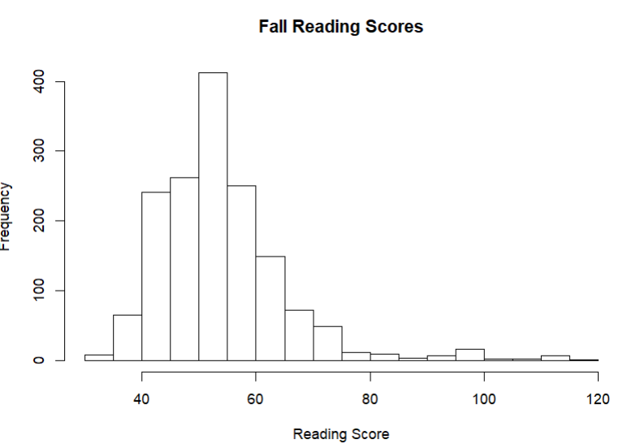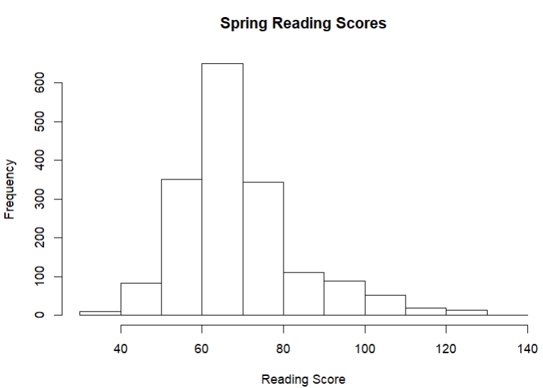

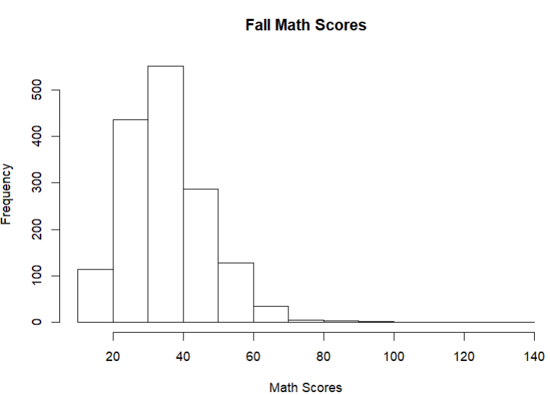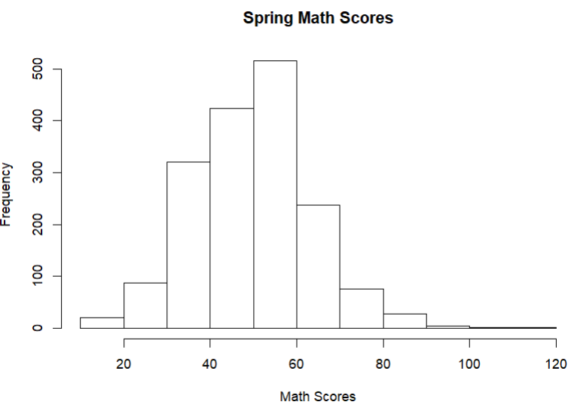

B. Boxplots
Next, create a boxplot for each of the same four variables to further examine their distributions.
Boxplots will help you identify the median, spread, and any potential extreme values in each variable. Present all four boxplots below. Each boxplot must include a clear title describing what is shown proper x-axis labels and y-axis labels.

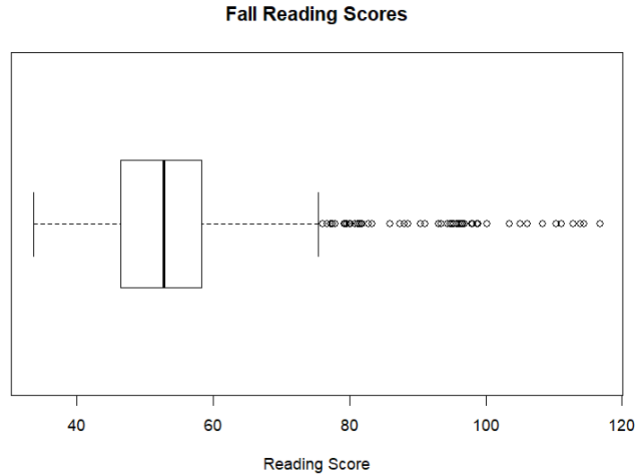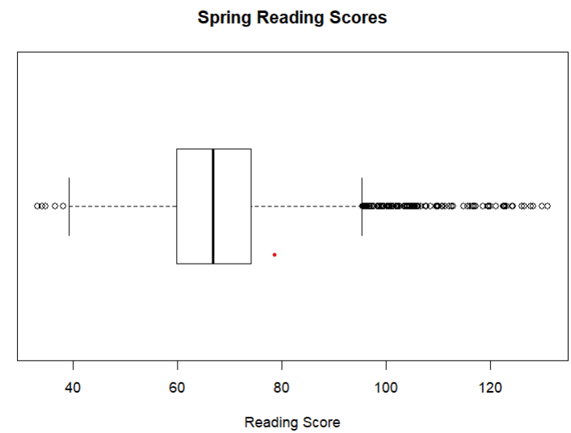

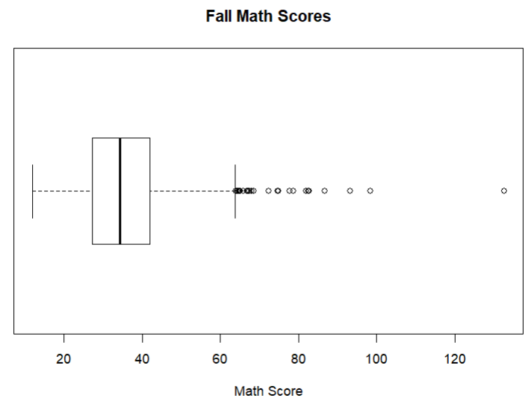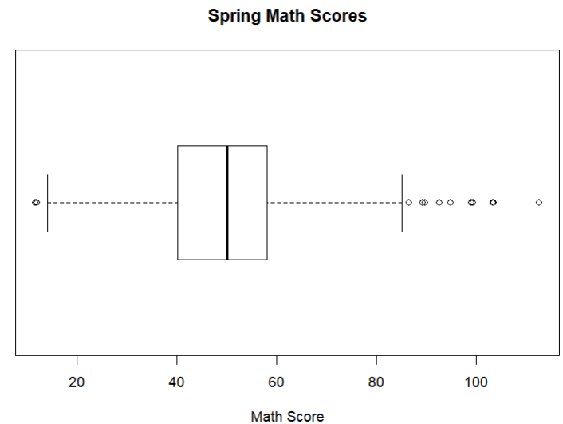

Task 3: Interpreting Distributions (20 pts)
Now that you have computed the descriptive statistics and visualized the data using histograms and boxplots, interpret what these results reveal about the distributions of the four assessment variables. Discuss the distribution of the four variables (X1RSCALK5, X2RSCALK5, X1MSCALK5, X2MSCALK5). In your response, refer to the numerical results and visual patterns you observed in the first two tasks (Descriptive Statistics, Histograms, and Boxplots).
Your discussion should address the following points:
- Whether each variable appears symmetrical, positively skewed, or negatively skewed
- Whether the distribution is leptokurtic (more peaked), platykurtic (flatter), or mesokurtic (approximately normal)
- How the shape of the distribution aligns with what you might expect for these assessments (e.g., reading and math scores improving from fall to spring)
Support your interpretation using both the numerical indicators and the visual evidence from your plots. Write your response in complete sentences as if you are writing for an academic paper or report.

- Are they providing a coherent paragraphs and sentences? Or are they just providing bullet points?

- Do they accurately reference numerical indicators (mean, sd, skewness, kurtosis) for each variable? Or are they misreporting numbers? Mark if you see any incorrect reporting (number that do not match the reported table) - 5 pts

- Do they correctly identify the direction of skewness (positive/right skew) for each variable? Mark if you see an incorrect interpretation of skewness. For example, the skewness value is 2, but they identify it as skewed to the left. Minor wording differences (e.g., “right-skewed” vs “positively skewed”) are acceptable.

- Do they correctly interpret the kurtosis value for each variable? Mark if you see an incorrect interpretation of kurtosis. They don’t have to use the words leptokurtic, mesokurtic, or platykurtic; they can use their own words to describe being flatter or more peaked compared to a normal distribution.

- Do they explain results in context (e.g., expected increase in scores from fall to spring indicating developmental trends; more variation in data in Spring)?

K-Fall Reading (X1RSCALK5)
- Skewness: Positively skewed (Sk = 1.82), confirmed by right tail in histogram and outliers above 100 in boxplot.
- Kurtosis: Leptokurtic (K = 5.70), indicating a sharper peak and heavier tails than normal.
- Interpretation: Most students scored around 50–60, with a few much higher performers.

K-Spring Reading (X2RSCALK5)
- Skewness: Positively skewed (Sk = 1.17), less skewed than fall.
- Kurtosis: Slightly leptokurtic (K = 2.14).
- Interpretation: Distribution shifted rightward (Mean = 68.91), showing expected improvement in reading skills by spring.

K-Fall Math (X1MSCALK5)
- Skewness: Positively skewed (Sk = 1.09).
- Kurtosis: Leptokurtic (K = 4.10).
- Interpretation: Similar to reading, most scores cluster between 30–40 with a few higher outliers. Indicates variability in early math readiness.

K-Spring Math (X2MSCALK5)
- Skewness: Mildly positively skewed (Sk = 0.29), approaching symmetry.
- Kurtosis: Slightly platykurtic (K = 0.51), indicating a flatter distribution compared to Fall.
- Interpretation: Mean increased to 49.73, and distribution became more normal as students’ math performance converged over the year.

Task 4. Conditional Descriptive Statistics by Home Language (20 pts)

In this task, you will compute the descriptive statistics for the variable X1RSCALK5 (Fall Reading IRT scale score) conditional on home language status (X12LANGST).
This means you will calculate the statistics separately for each home language group:

- Non-English (1)
- English (2)
- Undetermined* (3)

* “Undetermined” indicates that no single primary language could be identified, or two languages are spoken equally at home.

Using these groups, compute and report the following statistics: Sample Size (N), Mean, Standard Deviation (SD), Minimum (Min), Maximum (Max), Skewness, and Kurtosis. Round all values to two decimal places when reporting.

The describeBy() function in the psych package allows you to quickly generate descriptive statistics for one variable grouped by another variable. Here is an example showing how to compute statistics for X1RSCALK5 by home language status (X12LANGST):

library(psych)

# Compute descriptive statistics for X1RSCALK5
# by home language status

describeBy(x = ecls$X1RSCALK5, group = ecls$X12LANGST)

This command will display a separate set of statistics for each group in the variable. Use these values to fill in the table below.

Table XX.

Descriptive Statistics for IRT scale scores from the Fall Kindergarten Assessment Conditional on the home language status

 | N | Mean | SD | Min | Max | Skewness | Kurtosis
Home Language Status
English | 1153 | 55.29 | 11.66 | 33.70 | 116.78 | 1.83 | 5.55
Non-English | 225 | 51.21 | 11.17 | 34.38 | 111.12 | 2.06 | 6.86
Undetermined¹ | 17 | 49.32 | 6.85 | 38.55 | 61.61 | -0.10 | -1.11
¹ Can't choose a primary language, or two languages are spoken equally

Task 5. Exploring Conditional Distributions (20 pts)
A. Grouped Boxplot
In this task, you will create a boxplot that displays the Fall Kindergarten Reading Assessment scores (X1RSCALK5) conditional on home language status (X12LANGST).
Each subgroup—English, Non-English, and Undetermined—should appear as a separate box on the same plot. This visualization allows you to compare the central tendency, spread, and potential outliers across home language groups.
You can use the boxplot() function in R to create boxplots for a variable across groups.
# Create a boxplot of Fall Reading IRT scores by home language status

boxplot(X1RSCALK5 ~ X12LANGST,
data = ecls,
main = "Fall Kindergarten Reading Scores by Home Language Status",
xlab = "Home Language Status",
ylab = "Reading IRT Scale Score",
names = c("Non-English", "English","Undetermined"),
col = "lightblue")
- X1RSCALK5 ~ X12LANGST tells R to plot reading scores (X1RSCALK5) by the grouping variable (X12LANGST).
- data = ecls specifies the dataset.
- main, xlab, and ylab label the title and axes clearly.
- The names argument customizes group labels for readability
- col adds a color fill to make the plot visually clearer (optional).
Present one figure containing the three boxplots side-by-side.
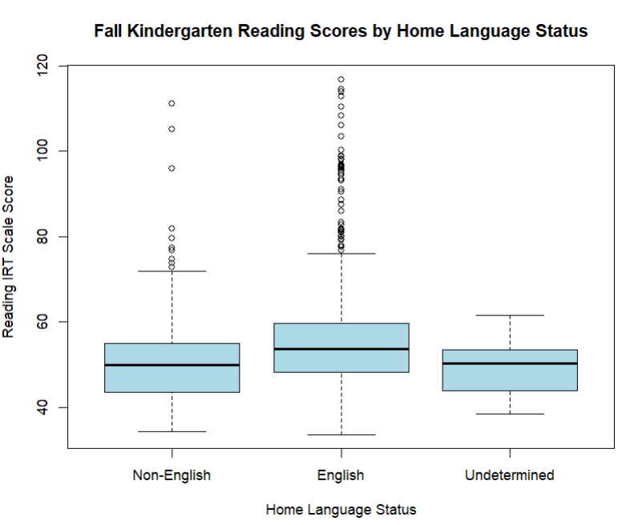

B. Discussion of conditional distributions

Interpret and compare the distributions of the Fall Kindergarten Reading Assessment scores (X1RSCALK5) across the three home language status groups. Use all of the information you have gathered from descriptive statistics and grouped boxplot to support your discussion.

In your response, address the following points:

- Center: Which group shows the highest and lowest average reading scores?
- Spread: Which group’s scores are more or less variable?
- Skewness and Kurtosis: What do these values suggest about the shape of each group’s distribution (e.g., symmetry, peakedness, or flatness)?
- Overall Comparison: Are the distributions similar or different across the three home language groups? What patterns or trends do you notice?

Write your discussion in complete sentences, integrating both numerical evidence and visual evidence. Be specific in describing how each group’s performance compares and what these differences might suggest about early reading development across language backgrounds.

- Do they correctly identify and compare mean reading scores; discusses which group has the highest and lowest average. Mark if they do not.

- Do they accurately compare variability using an appropriate statistic (e.g., SD, range, IQR, whisker length). Mark if they do not.

- Do they interpret the shape (symmetry, peakedness) of each group’s distribution using the provided statistics? Mark if they do not.

- Do they provide a cohesive summary comparing all three groups, connecting results to meaningful patterns in reading development? Mark if they lack a summary or discussion of comparing distributions, or they misinterpret what they see.

